M.A. Jones Elementary School

Date: September 11, 2025

Time: 419pm-5:36pm

Location: Zoom & [YouTube](https://www.youtube.com/@majones9931)

1. Call to Order: 4:19pm
2. Roll Call

|  |  |  |
| --- | --- | --- |
| **Role** | **Name** | **Present or Absent** |
| Principal | Teruko Dobashi | Present |
| Parent/Guardian | Ayana Dunston | Present |
| Parent/Guardian | Meghan Plumb | Present |
| Parent/Guardian | Shyretha Sheats | Present |
| Instructional Staff | Janni Buggs | Present |
| Instructional Staff | Cole Pryor | Present |
| Instructional Staff | Latoya Bostic | Present |
| Community Member | Melissa Waller | Present |
| Community Member | Raquel Hudson | Present |
| Swing Seat | Krista Verdelotti | Present |

Full attendance. Quorum is met.

1. Action Items
   1. Approval for Agenda
      1. MOTION: Verdelotti
      2. SECOND: Plumb
      3. RESULTS: Motion passed unanimously
   2. Approval of [Previous Minutes](https://www.atlantapublicschools.us/cms/lib/GA01000924/Centricity/Domain/10662/Final%20MAJ%20Meeting%20Minutes%20August%2019%202025.pdf) of August 19, 2025
      1. MOTION: Dunston
      2. SECOND: Bostic
      3. RESULT: Motion passed unanimously
2. Discussion Items
   1. School Strategic Plan
      1. Strategic Plan & Priorities
         1. 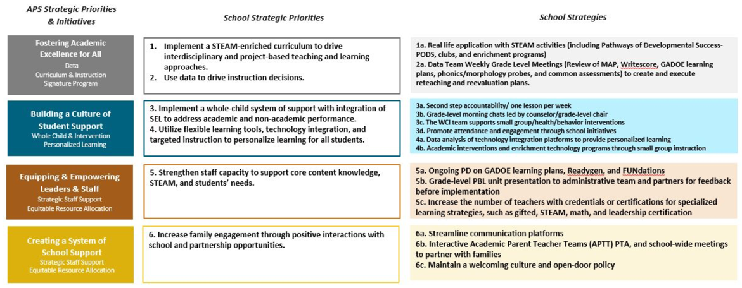
      2. SMART Goals
         1. 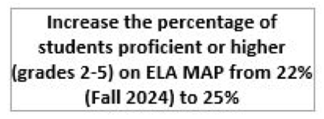
         2. 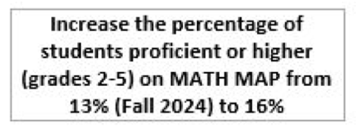
         3. 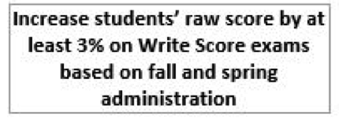
         4. 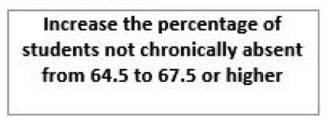
   2. Data Discussion
      1. MAP Results & 2025 GA Milestones Results
         1. (after slide 6) Dunston asked if we could add students to read at EOM Ceremony something they wrote from the month to help with WriteScore’s.
            1. Dobashi loved the idea and noted it!
         2. (Slide 8) Highest Average of Growth of 60% of students:
            1. K: 48%
            2. 1: 53%
            3. 2: 21.6%
         3. (Slide 13) for GMAS charts- Red: Beginning Learner; Yellow: Developing Learner; Green: Proficient Learner; Dark Green: Distinguished Learner

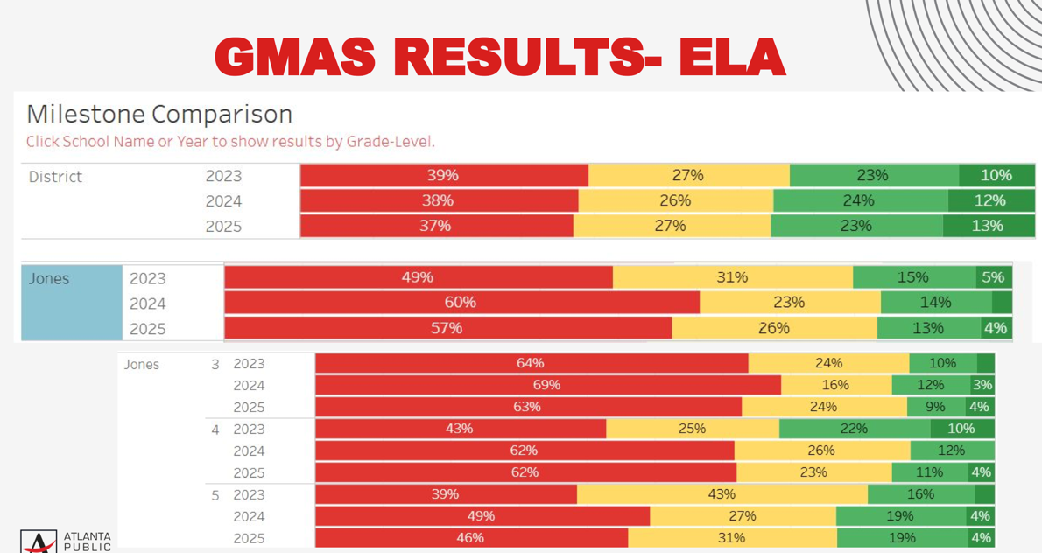

* + - * 1. Progression growth for the 3 year view:

2023: 3rd graders (64%) > 2024: 4th grades (62%) > 2025: 5th graders (46%)

2024-2025 is a ~10% jump for 3rd graders.

* + - 1. (Slide 14): If there is no marking, it is NOT tested. The percentage listed are Proficient Learners. The gray bar is district average.

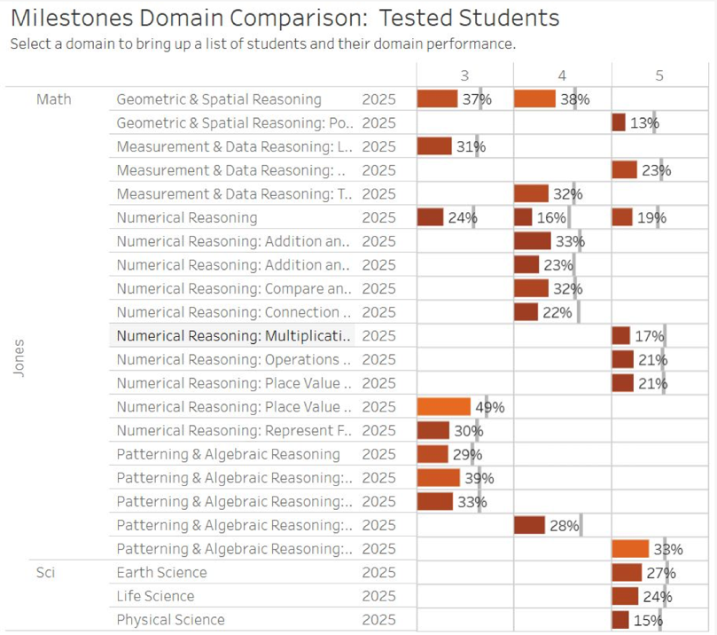

* + - * 1. EX: (first line item) 37% of 3rd graders are Proficient Learners in Geometric & Spatial Reasoning
      1. (Slide 16): Writing Domains for 5th graders are above district average on Informational/Explanatory Trait

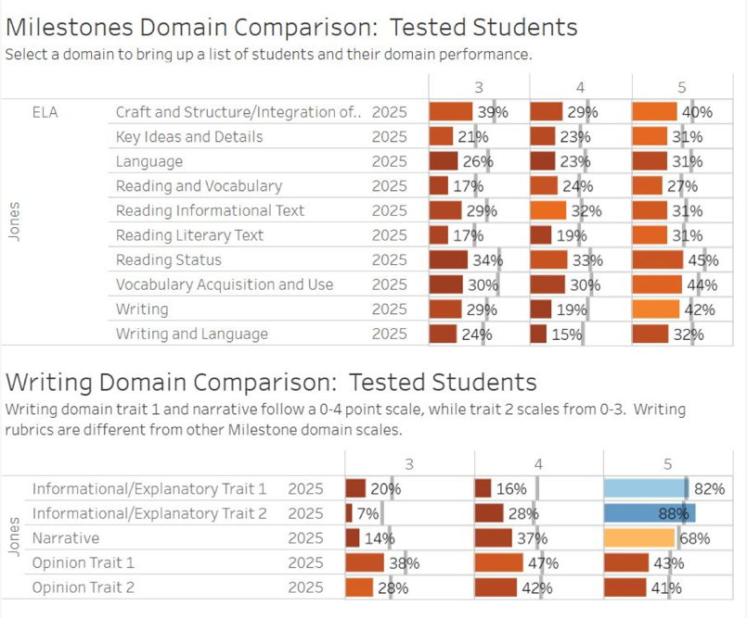

* + - 1. (Slide 20)

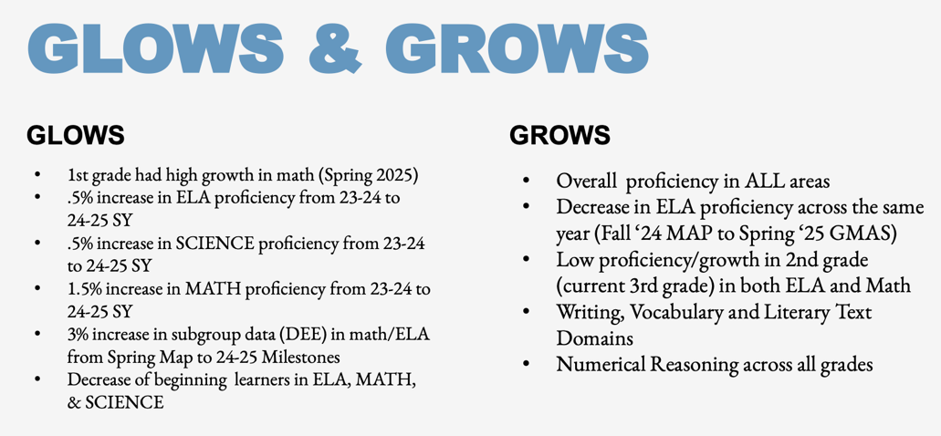

* + - * 1. Pryor: Teacher tutor with students that need the extra help in first grade is great. The transition is shocking to a lot of students coming into second grade; especially when MAP testing is so early in the year of second grade.
        2. Verdelotti: Since we live in high transient neighborhood, can MAJ review students that have been at MAJ since PreK to 4th/5th grade to see how their testing is?

Yes, admin can.

* + - * 1. Buggs: Considering tutoring help for students at home? Paper Education: K-12 Tutoring app. There are live tutors. Parents can type the question in for help. It’s a smaller group of students.

Make sure parents know of support help for students at home.

* + - * 1. Pryor: If we don’t invest in the students during their foundation years, the gaps increase and the student’s work ability is more limited. The teacher tutors in 1st and 2nd grades will, in the long run, leave our school better so we don’t have to be so intense with redamation on 4th and 5th graders.
        2. Dunston: The WriteScore is higher than district, how can we achieve this in lower grades? Was this a different curriculum, was it the cohort, do we know?

Dobashi: It was the teachers. They had them writing every day.

1. Information Items
   1. Principal’s Report
      1. Enrollment and Leveling Updates

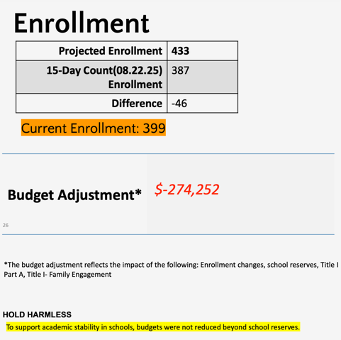

* + 1. We did NOT get any of these line items:

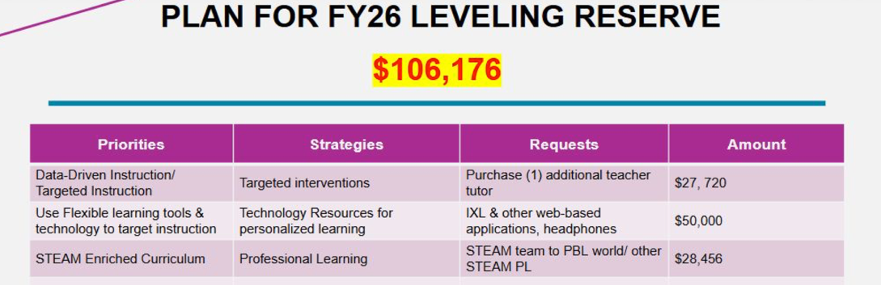

* + - 1. MAJ used “school funds” to purchase Lexia for DEE & Tier III students.
  1. [APS Forward 2040—Comprehensive Long-Range Facilities](https://www.atlantapublicschools.us/aps2040)
     1. Verdelotti is a Task Force Member.
        1. [Scenarios are out](https://www.atlantapublicschools.us/cms/lib/GA01000924/Centricity/ModuleInstance/128868/APS_ScenarioSlides_v3.pdf): 2 of the 3 are MAJ closing as we know it.
           1. A lot of public meetings for feedback.
        2. Next scenarios come out early October.
        3. As of now, next meeting is [October 20 @ 12noon online](https://zoom.us/meeting/register/fIL2REqgQM6tgdATMqp78g#/registration) & 6PM in person at CLL.
        4. GO Team Facilities meeting was supposed to be today but is going to be rescheduled.
           1. Jocobi is waiting for next round of scenarios before GOTeam meeting on facilities.
     2. Dunston: the 3rd scenario is close FL Stanton and move the students from Douglass Cluster to Washington Cluster.
  2. Professional Learning: [Metro RESA Training](https://www.mresa.org/resourcescontent-areas/whole-child-supports/professional-learning-offerings). Metro RESA is the state. GMAS is created by the state. Metro RESA is sharing what the state is looking for. Benchmark is a curriculum that is for the nation.
     1. MAJ Training this year
        1. (3) Metro RESA Math Training
        2. (3) Metro RESA ELA (Writing) Training
        3. (5) staff attending Readers League Training in October
        4. (5) staff attending Readers League Training in October
     2. $650 for 4 hours or $1,300 for full day
        1. 12-2pm with DSE teachers
        2. 2-4pm with whole staff
  3. Metro RESA & Benchmark Discussion with Bostic, Pryor and Buggs.
     1. Verdelotti: How does Benchmark tie into “My Backpack” with Amira and Savvas?
        1. Dobashi: Benchmark is separate. Savvas is used for math, students can access math workbooks. Amira is a testing platform instead of MAP Growth & MAP Fluency. Benchmark has “magazines” for their workbooks—it lasts about 15 days.

1. Announcements
   1. TONIGHT, Thursday, September 11, 2025: PTA Meeting, 7pm @ online/google meet!
   2. Wednesday, September 17, 2025: Cluster Table Talk, 6pm @ Hunter Hills Baptist Church
   3. Wednesday, September 24, 2025: Science Fair Launch Night, 3-4pm @ MAJ.
   4. Thursday, September 25, 2025: Picture Day
   5. Friday, September 26, 2025
      1. EOM Celebration, 1pm @ MAJ
      2. PTA Skate Night, 6pm @ Cascade Skate Night
   6. Saturday, September 27, 2025: GO. Grow. Govern for GOTeam Training, 830am-230pm
      1. Registration isn’t open for this yet.
   7. Monday, September 29-Friday, October 3, 2025: Parent Teacher Conferences
   8. Friday, October 3, 2025: Writing Publishing Party, 1-2pm @ MAJ
2. Public Comment
   1. Monthly Updates on the status of GADOE REcertification? Where we are on achievement, what’s been completed, what’s outstanding, any meetings?
      1. A monthly “WOW” session: partners come in Community Food Bank, STEAM walks with the state came in and supported a grade level.
      2. We put up the first wave of bulletin boards at MAJ: “what did the way say?” Does the wall really reflect what we are doing?
         1. Dr. Edwards (liaison between state and school) is over STEAM certification this year. MAJ is on track to submit documents within the next 2 months.
   2. Facilities Task Force: Krista V.
3. Adjournment
   1. MOTIONED: Verdelotti
   2. SECONDED: Bostic
   3. RESULT: Motion passed unanimously

ADJOURNMENT at 5:56PM

--------------------------------------------------------------------------------------------------------------------------

Minutes Taken By: Krista Verdelotti

Position: Secretary

Date Approved: